**Part 1 – Get Twitter Data**

* pip install requests_oauthlib
  + requests is a standard Python library for handling Web requests and responses. In order to conform to the Twitter authorization specifications we load a requests authorization plugin.
* **Get Twitter Keys** **and modify twitterstream_requests.py**
* **For video tutorial visit:** <https://youtu.be/NQr6qY2maOk> begin at 2:50 for this part of the assignment
  + These steps will help you set up your twitter account to be able to access the live 1% stream.
    - Create a twitter account if you do not already have one.
    - Go to <https://apps.twitter.com> log in and click “Create New App”.
    - Fill out the form and agree to the terms. Put in a dummy website id you don’t have one that you want to use.
    - On the next page, click the “API Keys” tab along the top, scroll all the way down until you see the section “Your Access Token”

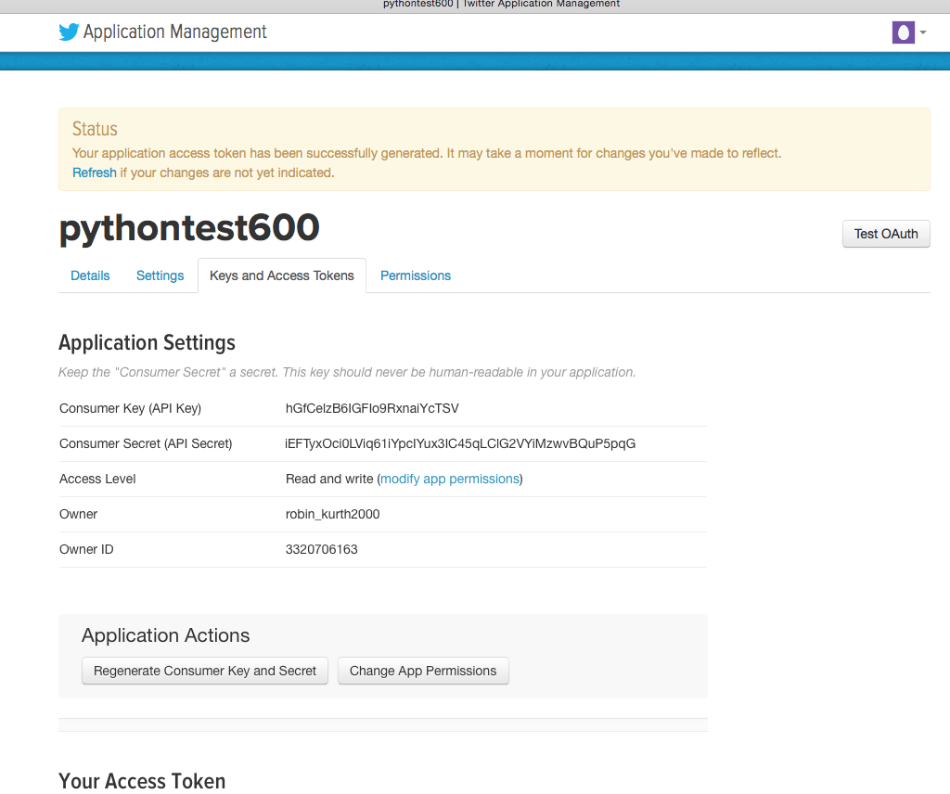

* + Using your editor (Sublime, PyCharm, Textedit…) open the **twitterstream_requests.py** file (attached) and copy the four values into **twitterstream_requests.py** – lines 6, 7, 8 & 9 – this is all you need to change in the **twitterstream_requests.py** file. Save the file with your keys. See the screen shot below for how your file will initially look and then how it will look once you have entered your unique keys. *I am using Sublime here so yours may look different depending on which editor you use*.

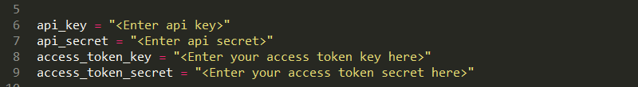

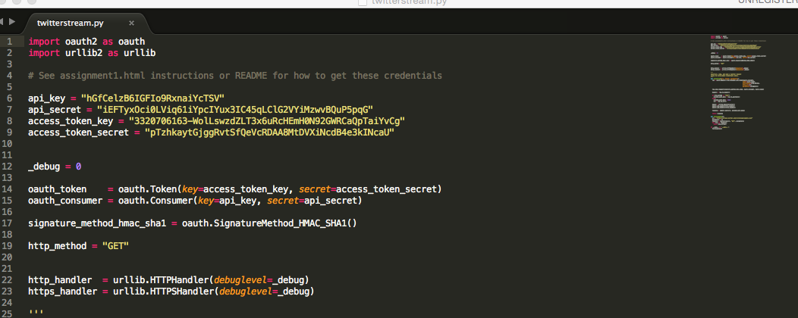

* **Generate your output.txt file**
  + Once you have your **twitterstream_requests.py** saved, open up your Command Prompt or Terminal and execute the following command: ***python twitterstream_requests.py > output.txt***
  + Hit ctrl + c to stop the file. It may appear that nothing is happening at first, this is fine. Once you hit ctrl + c this will stop the file from running and you will have generated an output.txt file.
  + Keep the newly created **output.txt** file for week 2.
    - This will not work if the **twitterstream_requests.py** file is not in the correct folder. You will receive an error, if you do type **ls** and all your files will appear for the location that you are currently in, if you do not see the **twitterstream_requests.py** file there, move it there and try the command again.

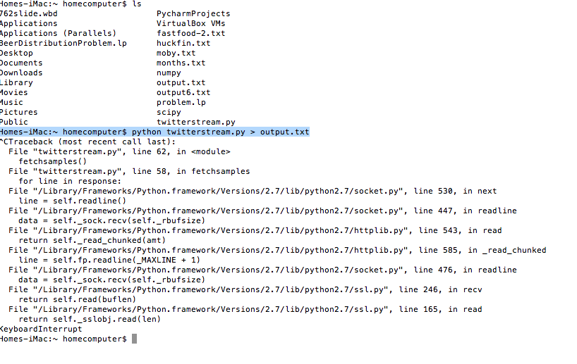

* Sample showing the new **output.txt** file in my folder:
  + Let it run long enough to get it up to ~30 – 50 MB, okay to run the command again and write over the file you just created if it is not large enough.

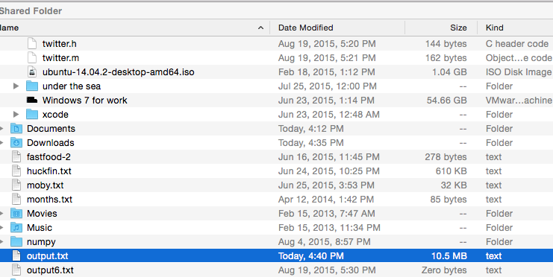

* **For a sample of a typical output file see below**

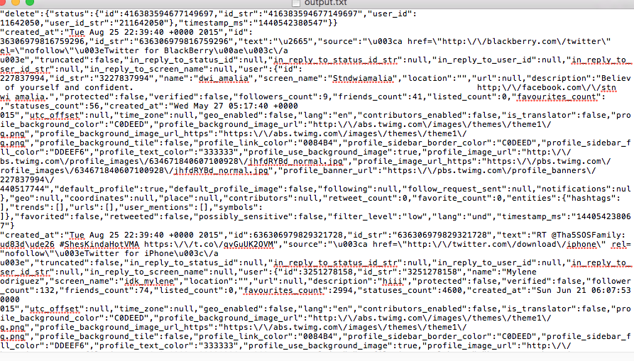

* This concludes part 1 of the assignment – part 2 will be posted in week 3. Create a word document, explaining your process and steps, include screen shots (similar to what I have provided for you here) and drop in the drop box (*Sentiment Analysis using Python)*.